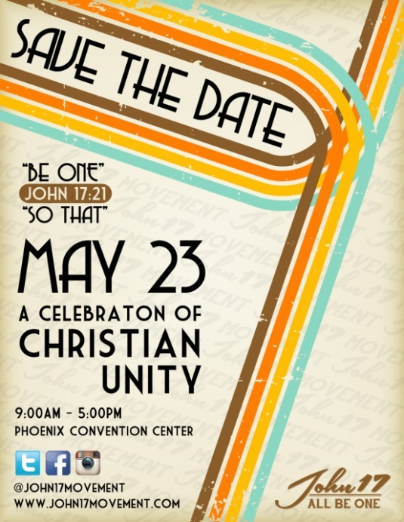
A CELEBRATION OF CHRISTIAN UNITY
May 23, 2015 – Phoenix Convention Center
9 AM to 5 PM

Sponsored by the John17 Movement www.john17movement.com

FACT SHEET
Cooperating Organizations
American Bible Society, New York, NY – Robert Briggs
Ark Sciences, Phoenix, AZ – Joe Tosini
Catholic Renewal Ministries, Phoenix, AZ – Marge Chavez
City of the Lord, Tempe, AZ – Peter Poppleton
Community of Jesus, Bari, ITALY - Matteo Calisi

Diocese of Phoenix, Phoenix, AZ – Bishop Thomas Olmstead and Auxiliary Bishop Eduardo Nevares
Evangelical Church of Reconciliation, Caserta, ITALY – Giovanni Traettino
Grace Unlimited, Phoenix AZ - Gary Kinnaman
Mike Herron Ministries, Houston, TX - Mike Herron
Renovación Carismática, Phoenix, AZ – Rosa Elena Cruz Muniz
Organizations represented by the Minister Team
Apprenticeship to Jesus, Phoenix, AZ – Ryan Thurman
Campus Christian Center, Tempe, AZ – Ben and Sarah Sanders
Church of the Remnant, Phoenix, AZ – Warren Stewart
City Serve, Phoenix, AZ – Billy Thrall
Kineo Urban Renewal, Phoenix, AZ – Jeff Skeens
Phoenix/One, Phoenix, AZ – Jeff Gokee
Renew, Phoenix, AZ – Justin Venson
Special Assistance provided by
Living Streams Church, North Central Phoenix, AZ
Our Lady of Mount Carmel Parish, Tempe, AZ
St. Mary’s Parish, Chandler, AZ

About the John 17 Movement
VISION
The John 17 Movement longs for a world where no one is separated from a loving, restoring and life-changing relationship with God the Father, through Jesus Christ His Son, in the power of the Holy Spirit and in community together.
We envision Christ’s One Church living in reconciliation and unity, offering to each other our unique and beautiful gifts as we daily increase in our passion to serve those around us in Christ’s name and for God’s glory.
Such radical discipleship – rooted in Christ’s community of friendship - is what will rise above the clutter of the culture around us and demonstrate to a watching world the restoration they so long for as we obey Jesus’s command to love God and our neighbors in desperate need of the transforming hope of the gospel.
VALUES
The John 17 Movement is:
- A call to the 21st century church to embrace and respond to the profound message of unity from The Jesus Prayer found in John 17.
- An opportunity to plumb the depths of The Jesus Prayer to understand God’s heart and mind.
- An expression of the heart of Jesus Christ: to bring us into the unity that exists in the Holy Trinity, providing the opportunity to experience a bit of Heaven now.
- A call to the church to express the most effective apologetic for the claims of Jesus, by being One in front of a watching world.
- An uncontrollable force from Heaven, a movement that the Holy Spirit is initiating and will sustain.

- An opportunity to repair the brokenness of the body of Christ in the context of prayer, Scripture, and fellowship among all the streams of Christianity, including Catholics, Orthodox, and Protestants who align with historic Christian orthodoxy as expressed through the Apostle’s Creed.
- Undergirded by the entire body of Scripture, both Old and New Testaments, which carries a pervasive theme of relational unity.
- A growing movement demonstrating God’s benevolence at this critical moment in church history.
The John 17 Movement is not:
- A statement of church doctrine. John 17 Movement participants will leave it to the Holy Spirit and other forums to address hermeneutical matters of doctrinal interpretation.
- A defined strategy for church planting. The more we try to define it prematurely, the further away we will get from what the Lord intends to birth. Participants are only beginning to scratch the surface as to what the Holy Spirit’s intention is when we pray John 17.
- A platform for individual leaders or ministries to promote their brand or their agenda.

Relationships
We believe that with God unity is possible. This belief energizes and mobilizes us to engage in the important work of healing and reconciliation. (Mark 9:23)
We cannot only pray and advocate for relational bridge building. We must engage in the difficult work of putting our beliefs into action. God calls us to repent, even when it is painful. God calls us to forgive, even when it seems impossible. God desires that we face the truth of who we are, which means that we must be willing to ask forgiveness of those whom we have wounded, to whom we have failed to show the great love of God. God leads us on the path to reconciliation. God desires for us to be healers and peacemakers. (Matt. 5:9)

The John 17 Movement Leadership Team
JOSEPH TOSINI

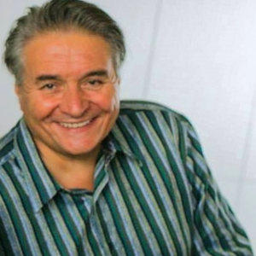
A high-energy visionary with rich experience in leading diverse teams for mission-based enterprises, including Christian organizations and private businesses, with the simple, but complex goal of making a difference in the world. Joe sees himself today as an ordinary man on a quest to make a difference. Earlier in his life, he often felt confused and hopeless, questioning the meaning and reason for everything going on inside and around him. But once he was able to connect with his purpose in life, everything changed. The fog of despair began to lift, as he decided to devote himself to making life better in a hurting world. As an ordained minister, Joe's mission-oriented work around the world has honed his ability to build relationships and influence change, while never losing sight of the big picture. He leads through friendship, teaching and giving with a strong belief that any person, no matter how ordinary one feels, can choose to do extraordinary things. Joe has authored several books dealing with conflict resolution in families and organizations. His books include "She Called Me Dad" and "Is There Not A Cause?: Beyond the Disappointment of Aimless Christianity". Joe and his wife Mary have five children and four grandchildren.

PETER & SHARON POPPLETON
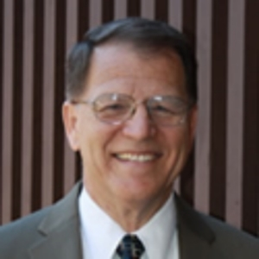
Peter and Sharon have been married for over thirty-five years. They have three sons and five grandchildren (so far). He has worked in publishing companies for the Catholic Church in the area of faith formation for over 30 years and has spoken at the diocesan level throughout the Southwest. Sharon and Peter have attended leadership-level conferences in the United States, France, Assisi, and Rome. Their particular focus has been creating an active and intentional Catholic Christian Culture in the home and building Christian community. Peter currently serves as Overall Coordinator of City of the Lord, a Covenant Community located in Arizona and California. The community has received both Pontifical Right in the Catholic Church and been recognized as a Private Association of Diocesan Right in the Diocese of Phoenix, Arizona.

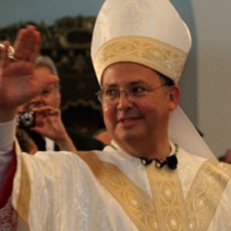
AuxilIary BISHOP EDUARDO NEVARES
Bishop Eduardo Alanis Nevares hails from the great State of Texas, being born in San Antonio, and raised in Houston. At the age of 14, Eduardo left his parents and his three brothers and one sister, and entered the high school seminary, St. Henry's Prep Seminary in Belleville, Il. Graduating from high school, he began his Philosophy studies at the La Salette Seminary in Altamont, N.Y. After two years, he finished his Bachelor of Arts degree in Philosophy at the University of St. Thomas in Houston. Following one year of Spiritual Exercises, he travelled to Kenrick Archdiocesan Seminary in St. Louis, MO, where he completed four years of Theology and received his Masters of Divinity degree. He was ordained a Transitional Deacon in November, 1980, and was ordained a Roman Catholic Priest on July 18, 1981, for the Missionaries of Our Lady of LaSalette. As a Missionary Priest, he has travelled the world over, and served the People of God through his Preaching and Sacramental ministry in English, Spanish and French. He has served as the Associate Pastor and later, as the Pastor of St. Patrick Parish in Lufkin, TX for seventeen years, and has served as the Vocation Director for the Diocese of Tyler, TX for seven years. Bishop Nevares served as the Catholic Chaplain to Stephen F. Austin University Campus for two years, and was later assigned to the Pontifical College Josephinum in Columbus, OH for another two years where he served as Vice Rector in charge of the College. On April 27, 2010, Pope Emeritus Benedict XVI named him Auxiliary Bishop for the Roman Catholic Diocese of Phoenix, where he serves together with Bishop Thomas J. Olmsted. Bishop Nevares was ordained to the Episcopacy on July 19, 2010, and continues to "Serve the Lord with Gladness" to the present day.

ROBERT BRIGGS

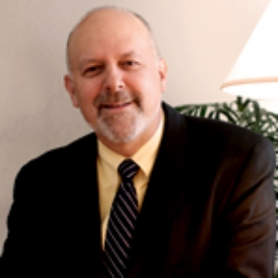
As the presidential liaison for American Bible Society, Robert Briggs works to strengthen the organization’s relationships with critical global partners. Working closely with American Bible Society’s president, Briggs is helping to open new opportunities for a third century of mission. Briggs has served in several roles at American Bible Society since he joined the organization in 1999. First, he led the fund development teams for five years before transitioning in 2007 to oversee the launch of Global Scripture Impact, American Bible Society’s research arm. A Global Council Member of the United Bible Societies, chairman of the Nominations Committee and a member of the Executive Board of the Forum of Bible Agencies-North America, Briggs oversees American Bible Society’s partnerships with the world’s Bible agencies. Additionally, as a member of the Every Tribe Every Nation (ETEN) Steering Committee, Briggs is on the front lines of Bible translation, working alongside the largest Bible agencies in the world to accelerate the digitization of existing translations and the development of new translations. Briggs is a graduate of the University of Missouri and, before joining American Bible Society, held leadership roles with the American Diabetes Association and Cityhill (a Christian publishing company). He and his wife have five adult children and two granddaughters.

GIOVANNI TRAETTINO

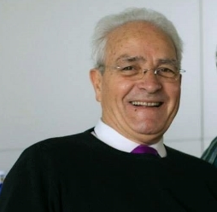
Giovanni Traettino is the Pastor of the Evangelical Church of Reconciliation in Caserta, Italy. He has an apostolic ministry to a network of churches in Italy and in the Central African Republic. With an appetite for the harmony and the eminence of the Body of Christ, he initiated negotiations for reconciliation between Evangelicals and Catholic Charismatics. Pastor Giovanni resides in Bari, Italy with his wife Franca and two children.
In July, 2014, Pope Francis made international news when he visited Pastor Traettino and his congregation at the Evangelical Church of Reconciliation. The Pope addressed his Evangelical and Pentecostal brothers and sisters about “Unity in Diversity” through the power of the Holy Spirit. And, in the spirit of reconciliation, Pope Francis asked church members for forgiveness for any hand Catholics might have had in the persecution of Evangelicals in Italy in the 1930s.

MATTEO CALISI

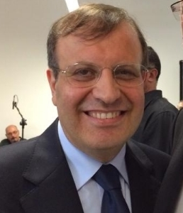
Professor Matteo Calisi, born in Bari (Italy) on 11th February 1958, is married to Giovanna De Pascalis and they have two sons, Daniele and Francesco. Matteo studied Music at the Conservatoire, and Theology and Byzantine Studies at the Ecumenical Faculty of Bari, Italy. Having been involved in Roman Catholic charismatic renewal since the 1970s, Matteo, together with his wife, founded the Community of Jesus in May 1983. The Community is committed to a three-fold ministry of worship, the reconciliation of Christians, and evangelism. It was significantly shaped by input into Matteo’s life from two men, Cardinal Suenens and David du Plessis. At Rimini in 1978 Matteo met Cardinal Suenens, one of four moderators of the Second Vatican Council and a supporter of the renewal movement. Through further meetings at the Vatican their friendship developed and the Cardinal encouraged Matteo to start the Community of Jesus, with its particular emphasis on unity and reconciliation within the Body of Christ. With the encouragement of Cardinal Suenens, Pope John XXIII had invited David du Plessis, a Pentecostal minister with a passion for the unity of the Church, to attend the Second Vatican Council. In May 1981 Matteo attended an international conference in Rome at which David du Plessis was one of the speakers. As Matteo talked with David, a defining moment took place which was to set the direction for Matteo’s future ministry. The minister took off his own lapel badge depicting – “70 x 7” – a reference to Jesus’ words on the need to forgive, and pinned this onto Matteo, saying “My dear son, may you become an ambassador of reconciliation.” Over the following years this call on Matteo’s life has been acknowledged by the Vatican and also recognized by many leaders within other denominations. Supported by the Community of Jesus, the work of reconciliation has led him to minister in an international context, co-operating with many ecumenical organizations. Within the Roman Catholic setting Matteo has served as Vice-President of the International Catholic Charismatic Renewal Services (ICCRS) and President of the Catholic Fraternity of Charismatic Covenant Communities and Fellowships (CFCCCF). On the 11th March 2008 he was appointed as a Member of the Pontifical Council for the Laity. Matteo continues to be encouraged in the work of reconciliation by Pope Francis.

MIKE HERRON
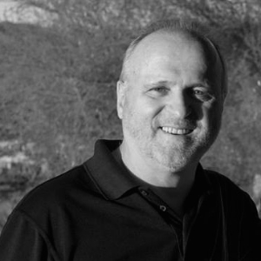
Mike Herron is a pastor and psalmist who travels throughout the world preaching the Good News of Christ, leading worship concerts, teaching Seminars and speaking at a variety of events. He is a pianist and composer with six recordings as well as the author of two books. Mike began in full time ministry in 1974 as a worship leader and became the founding pastor of Life Church in Salem, Oregon. He has also served the Lord as the International Director of Ministers Fellowship International; as the director of Canzion Music; as a part-time pastor in the worship department of Lakewood Church in Houston and as the Vice-President of ‘Integrity Music Latin’ in Mobile, Alabama. Mike has a Master’s Degree in Practical Theology from Oral Roberts University. He and his wife Marsha have 3 children and 8 grandchildren and are members of Lakewood Church in Houston, Texas. He enjoys golfing and walks with Marsha and their chocolate Lab, Ginger.

GARY KINNAMAN

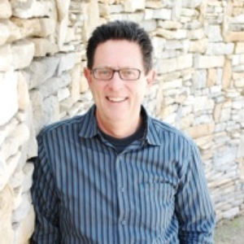
Gary Kinnaman served as Senior Pastor of Word of Grace Church for twenty-five years. Under his leadership, the church grew to an average weekend attendance of over 4500. He now serves as a pastor at large, mentoring and networking church, government and market place leaders to serve the Phoenix area. His leadership in this regard led to his appointment to Chairman of the Governor’s Council on Faith and Community. Gary is a graduate of Biola University (B.A.), Arizona State University (M.A.), Fuller Theological Seminary (M.A. in Theology), and Western Conservative Baptist Seminary (D.Min.). A gifted communicator, Gary has written ten books, his most recent is the critically acclaimed, Seeing in the Dark: Getting the Facts on Depression and Finding Hope Again. Gary and his wife, Marilyn, who make their home in Gilbert, Arizona, have three adult children and eight grandchildren.

Fact Sheet - TIMELINE
DATE | EVENT
July 20-24, 1977 | Gary Kinnaman, Joe Tosini and Sharon Poppleton are among the almost 50,000 attendees at the KANSAS CITY CHARISMATIC CONFERENCE held in the summer of 1977 in Missouri.  Major prophecies are received revealing the Father’s disappointment and pain at the disunity in His church (“Come before me with tears and mourning, for the body of my Son is broken”) and His call to “Stand in unity with one another and let nothing tear you apart.”  http://revivalartifacts.blogspot.com/2014/09/22-minutes-of-kansas-city-conference.html
May 1981 | David du Plessis (“Mr. Pentecost,”) prays for Professor Matteo Calisi (Community of Jesus, Bari, Italy) to become “an ambassador of reconciliation.”
Early 1980s | Professor Matteo Calisi and Pastor Giovanni Traettino (Movement of Communion and Restoration, now renamed the Evangelical Church of Reconciliation in Caserta, Italy) begin a dialogue regarding the ministry of reconciliation.  Matteo, initiates dialogues in various countries with Pentecostal churches and other ecclesial traditions reached by the Charismatic Renewal, including some from the Messianic Jewish tradition.
1983 | Pastor Joe Tosini (from Missouri) and Pastor Mike Herron (from Oregon) travel to Caserta, Italy to attend a three-day worship conference being held at Giovanni Traettino’s Church.  Mike sees a man he does not know in the back of the room at the conference and is immediately impressed by the Spirit that this man is going to be used in a significant way in the Catholic Church. Mike and Joe pray over the man…Professor Matteo Calisi.
1992 | By invitation of Matteo Calisi, Giovanni Traettino speaks at a large Catholic Charismatic Conference in Bari, Italy. Pastor Traettino, in a gesture both humble and prophetic, washes the feet of a representative of the Catholic church.  Matteo and Giovanni found Cosultazione Carismatica Italiano (Italian Charismatic Consultation – CCI) a joint committee of Catholic and Charismatic Evangelicals and Pentecostals, and begin their worldwide efforts to spread the spirit of interchurch reconciliation.
Oct 31, 1999 | The Joint Declaration on the Doctrine of Justification is created, and agreed to, by the Catholic Church's Pontifical Council for Promoting Christian Unity (PCPCU) and the Lutheran World Federation in 1999, as a result of extensive ecumenical dialogue. It states that the churches now share "a common understanding of our justification by God's grace through faith in Christ.” To the parties involved, this essentially resolves the conflict over the nature of justification which was at the root of the Protestant Reformation.
2002  (-2013) |  | Matteo Calisi serves as President of the Catholic Fraternity of Charismatic Covenant Communities and Fellowships (CFCCCF). City of the Lord is a founding member of the Catholic Fraternity; COTL Overall Coordinator Bob Carmody serves on the Executive Board of CFCCCF. Peter Poppleton attends CFCCCF Rome meetings.
2006 |  | Matteo Calisi, Giovanni Traettino and others bring their “Gospel of Reconciliation” to a 6000-strong joint Catholic-Evangelical gathering in Buenos Aires where they meet with Cardinal Bergoglio (now, Pope Francis).  The World Methodist Council votes unanimously to adopt the Lutheran/Catholic Joint Declaration on the Doctrine of Justification
2008  (-2013) |  | Pope Benedict XVI appoints Matteo Calisi as a member of the Pontifical Council for the Laity with a focus on Christian unity.
March 13, 2013 |  | Cardinal Bergoglio of Argentina is elected as the 266th pontiff of the Roman Catholic Church and takes the name, “Francis.”
December 2013 |  | Wayne Rich, a Catholic convert (former member of Pastor Gary Kinnaman’s church) and his wife invite Bishop Nevares, Pastor Gary Kinnaman and his wife Mary to his home for dinner. Gary brings along his friends, Joe and Mary Tosini. Bishop Nevares requests, “Can’t we just pray together?”
January 2014 |  | Familiar with City of the Lord (COTL) from the Community’s founding membership in the CFCCCF, Matteo Calisi suggests involving COTL in planning for a unity prayer service in the Phoenix area. The planning meeting at COTL includes Peter Poppleton (now the Overall Coordinator for COTL), Joe Tosini, Gary Kinnaman and Bishop Nevares
February 18, 2014 |  | At the Diocese of Phoenix offices, meeting held with Bishops Olmstead and Nevares, Pastors Kinnaman, Tosini, and Giovanni Traettino; Matteo Calisi, Fr. Diskin, Peter Poppleton and Bob Carmody.
February 20, 2014 |  |  | Luncheon gathering of Evangelical Pastors with Bishops Olmstead, and Nevares at Living Streams Church in North Central Phoenix.
February 21, 2014 |  |  | Living Streams Church hosts a worship and prayer service attended by several hundred Catholics and Evangelicals including Bishop Olmstead, Bishop Nevares, Prof. Matteo Calisi, Pastors Giovanni Traettino, Gary Kinnaman, and Mike Herron, Robert Briggs from the American Bible Society and Peter Poppleton. Fr. Andryi Cherovsky, a Ukrainian Catholic priest who is also a member of City of the Lord, served as translator.
A letter is read from Pope Francis (via Pastor Traettino):

My brother (Giovanni),

You have kindly informed me that from 20-22 February next a Meeting of Reconciliation will be held in Phoenix between Evangelicals and Catholics, in which you will take part. This news
gave me great joy and made me more conscious of the need for reconciliation in this week in which we pray for Christian unity. (continued)
I hope that this meeting will draw down the Lord’s blessings so that we can persevere along the path to unity. We who have received the one baptism long for full communion; this is a grace of the Lord which we must fervently implore. In some parts of the world Christians are being attacked and rejected, at times violently. Those who attack us do not distinguish between Orthodox, Lutherans, Evangelicals or Catholics; they know only that these brethren are Christians. As far as they are concerned, we are all the same. And in these attacks many of our brothers and sisters have given their lives in witness to Jesus Christ. In such places they are experiencing the ecumenism of bloodshed, the ecumenism of martyrdom. This should impel us all the more to seek paths of unity in our daily lives.

Dear brother, I will accompany you with my prayers in these days of the Meeting, asking God’s blessings upon all taking part. By praying for one another, we exercise that spiritual ecumenism which accompanies all our actions. I ask you and all those taking part in the Meeting kindly to pray for me as well.

May the Lord bless all of you.
Fraternally, Francis
From the Vatican, 22 January 2014

February 22, 2014 |  |  | North Scottsdale Christian Church hosts a worship and prayer service attended by several hundred Catholics and Evangelicals including Bishop Olmstead, Bishop Nevares, Prof. Matteo Calisi, Pastors Giovani Traettino, Gary Kinnaman, and Mike Herron; Robert Briggs from the American Bible Society, and Peter Poppleton from City of the Lord.  Fr. Andryi Cherovsky, a Ukrainian Catholic priest who is also a member of City of the Lord, serves as translator.  Pope Francis letter is read again. The worship service includes a time of symbolically washing each other’s feet as a sign of reconciliation.
April 2014 |  |  | Joe Tosini and Matteo Calisi meet briefly with Pope Francis and discuss the reconciliation movement in the USA.
June 8, 2014 |  |  | With the support of Pastor Fr. John Bonavitacola, Pentecost Sunday Celebration is held at Our Lady of Mt. Carmel RC Church in Tempe, AZ. More than 750 Catholics, Pentecostals and Evangelicals gather for praise and worship. Talks are given by Joe Tosini, Bishop Nevares and Gary Kinnaman. This is the first significant participation in the John 17 Movement by the Catholic Renewal Ministries (CRM), English-speaking.
July 28,  2014 |  |  | Pope Francis makes international news when he visits Pastor Giovanni Traettino’s Evangelical Church of Reconciliation in Caserta, Italy and addresses and apologizes to his Evangelical and Pentecostal brothers and sisters. During the talk he focuses on “Unity in Diversity” through the power of the Holy Spirit. Matteo Calisi, Mike Herron and Joe Tosini attend the event.
September 2014 |  |  | A meeting in NY with the American Bible Society focuses on ABS becoming a formal partner with the John 17 Movement. The John 17 Leadership Team now includes Peter Poppleton, Bishop Nevares, Joe Tosini, Gary Kinnaman, Mike Herron and Robert Briggs. Matteo Calisi and Giovanni Traettino constitute the international members of the Leadership team.  While in New York, Sharon Poppleton connects with her cousin, Msgr. John Paddock, a priest in the Diocese of NY who happens to be a friend of NY Archbishop Timothy Dolan. Msgr. Paddock arranges a meeting between the John 17 Leadership Team and Archbishop Dolan. The Archbishop is very supportive of the John 17 Movement and is open to events being held in his Diocese.
November 2, 2014 |  | John 17 Ecumenical Gathering, a praise and worship event, is held at the Salvation Army Kroc Center in Phoenix. The program includes sharings by young leaders in the unity movement. Many attend from Catholic Renewal Ministries (CRM). Pastors and Ministry Leaders share, including Auxiliary Bishop Eduardo Nevares, Diocese of Phoenix; Joseph Tosini, John 17 Movement; Marge Chavez, CRM Coordinator of English Prayer Groups; Jeff Gokee, Executive Director of Phoenix One; Jeff Skeens, Pastor and Director of Kineo Urban Renewal; Warren Stewart, Pastor of Church of the Remnant; Chris Thyberg, American Bible Society and John Paul Poppleton, Worship Leader from City of the Lord.
November  11, 2014 |  | Peter and Sharon Poppleton attend and speak at the Catholic Fraternity (CFCCCF) Conference in Rome. Giovanni is there as well. Pope Francis speaks and focuses on the themes of “Unity in Diversity” and “Spiritual Ecumenism.” “Unity does not imply uniformity,” the Pope said. “It does not necessarily mean doing everything together or thinking in the same way. Nor does it signify a loss of identity. Unity in diversity is actually the opposite: it involves the joyful recognition and acceptance of the various gifts which the Holy Spirit gives to each one and the placing of these gifts at the service of all members of the Church.” Pope Francis also said: “I see that you have among you a very dear friend, Pastor Giovanni Traettino, whom I visited recently. Catholic Fraternity, do not forget your origins, do not forget that the Charismatic Renewal is, by its very nature, ecumenical….The Lord’s spiritual testament tells us that unity among his followers is not only the proof that we are his but also the proof that he is sent by the Father.”
January 17, 2015 |  | A smaller John 17 Unity Service is held at City of the Lord. Pastor John Armstrong, of the Act3 Network, shares his journey towards ecumenism.
January 24, 2015 |  | An Ecumenical Healing Service is held as part of Catholic Renewal Ministries’ annual conference. Conference Speakers include Jim Hyde (City of the Lord), Joe Tosini, Gary Kinnaman and Pastor Glen Kerby. A foot washing ceremony is conducted between members of the Charismatic Renewal members and representatives of the Evangelical/Pentecostal brothers and sisters.
February  2015 |  | John 17 Forward Team is established to handle administrative details of John 17 Movement events and activities. Led by Suzy Kraintz (John 17 Events Coordinator) and Dennis Ricardo (Event Coordinator, COTL) the team includes Ben and Sarah Sanders (Campus Christian Center), Marge Chavez (Coordinator for the English Catholic Renewal Ministries), Rosa Elena Cruz Muniz of Renovación Carismática (Spanish Speaking Catholic Charismatic Renewal), Rob DeFrancisco (Director of Communications Diocese of Phoenix), Brenda Fox, Robert Canzano, Phil Vierling, Rebecca Castellanos, Gabe Castellanos, and Pat Drechlser (Members of City of the Lord) as well as Kim Scoggin and Banni Hughs from Our Lady of Mt Carmel RC Church.
March 20, 2015 |  | A John 17 Unity Gathering for Praise and Worship is held at Living Streams Church. Ryan Thurman, from Apprenticeship to Jesus, leads the session which includes a time of communal prayer and asking forgiveness. Julio Torres, from St. Jude Episcopal Church, joins the music ministry which provides a bi-lingual program of music complete with projected bi-lingual translations.
May 23, 2015 (Pentecost Eve)  9 AM to  5 PM |  | 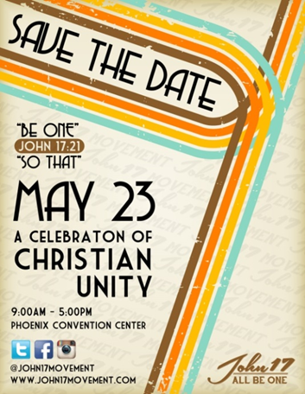  Area-wide “Celebration of Christian Unity” event scheduled for Phoenix Convention Center.

